|  |
| --- |
|  |
| Money3 Data Warehouse Project |
| Management Plan Version 1.0 |
|  |
| **Emma Wang** |
| **4/20/2017** |

|  |
| --- |
|  |

PURPOSE Of project

To be as the single source of truth of data source for analysis reporting (non-production use).

To have built in consistency of data source, data quality and definitions of measures across business.

High response time.

Background

Money3 have purchased Dimodelo Architect, Dimodelo Solutions’ Data Warehouse Automation tool.

Previous BI Developer, Dylan Harvey, engaged with Dimodelo for first version of data warehouse development. An interim data warehouse has been developed and in use for current power BI site and a few other reports.

Cost breakdown

<Please provide a high level breakdown of the costs associated with the project.>

Scope

The Scope of the Data Warehouse project is outlined in ‘Money3 Data Warehouse Matrix’ document located on shared drive.

architiect Data Models

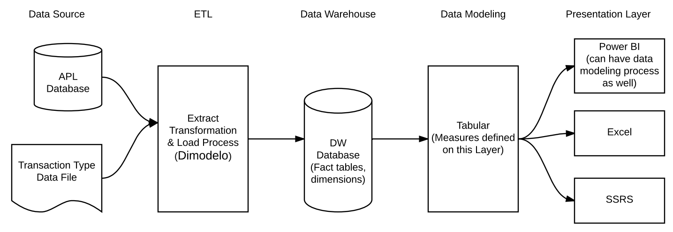

Project team

Dimodelo

Rob Camilleri

Kam Khangura

Toni Le

Emma Wang

Project deliverables

| Deliverable | Method of Quality Checking | Person Responsible | Planned Date |
| --- | --- | --- | --- |
| **Transaction fact** | Compare total transactions between DW database and APL database | Dimodelo, Emma | Done |
| Measures associated with above fact | Application Level testing. Verify measures by testing in Excel and compare with APL | Dimodelo, Toni |  |
| Reference fact | N/A | Dimodelo | Done |
| **Accumulating loan snapshot fact table** |  |  |  |
| Measures associated with above fact |  |  |  |
| **Periodic loan snapshot fact** |  |  |  |
| Measures associated with above fact |  |  |  |

Change control

Additions to scop will be recorded and all documents will be maintained at project shared drive.

E.g. Additional measures to fact or additional attributes to dimensions.

Change of calculation or definition to a measure.

Communication

Weekly online meeting with Dimodelo to discuss project progress, requirements details and projected related issues.

Weekly internal meetings.

Emails.

Milestones

| Stage: | | |
| --- | --- | --- |
| Milestone | Target Date | Status |
| Transaction fact and associated measures |  | To test |
| Accumulating loan snapshot fact and associated measures |  | Under development |
| Periodic loan snapshot fact and associated measures |  | To do |

timeline

Dimodelo is doing project tracking for development through Visual Studio Team Services.

<https://dimodelo.visualstudio.com/Money3/_backlogs/TaskBoard/?_a=requirements>

Please visit above site to see development tasks and progress. You need to get permission from Dimodelo to access the site.

Below chart is for internal user only to track tasks which are responsibilities of Money3, including but not limited to

* Provide definition of measures
* Details of change requests
* Testing
* DBA work
* Servers and software for testing and production

See Appendix 1

Appendix 1:

|  |  |
| --- | --- |
| Project Name: Money3 Data Warehouse | Date Prepared: 20/04/17 |

|  |  |  |  |  |  |  |  |  |  |  |  |  |
| --- | --- | --- | --- | --- | --- | --- | --- | --- | --- | --- | --- | --- |
| Phase, activity, task | Person Response. | Work effort | Timeline |  |  |  |  |  |  |  |  |  |
| **Transaction Fact and Measures** | 24-28/April | 1-5/May | 8-12/May | 15-19/May | 22-26/May | 29-2/Jun | 5-9/Jun | 12-16/Jun | 19-23/Jun | 26-30/Jun |
| Server & software support | Ning |  | CB |  |  |  |  |  |  |  |  |  |
| Iteration 1 input | Toni, Emma |  | CB |  |  |  |  |  |  |  |  |  |
| NAF-Definition 210217 | Toni, Emma |  | CB |  |  |  |  |  |  |  |  |  |
| Definition - Status entry | Toni, Emma |  | CB |  |  |  |  |  |  |  |  |  |
| Accumulate Snapshot Data definition | Toni, Emma |  | CB |  |  |  |  |  |  |  |  |  |
| Reversal Issue | Ning, Emma |  | CB |  |  |  |  |  |  |  |  |  |
| Transactions fact testing | Emma |  | CB |  |  |  |  |  |  |  |  |  |
| Transactions fact measures testing | Toni … |  | WIP |  |  |  |  |  |  |  |  |  |
| Change Request by Craig (new measures) | Kam, Toni, Emma |  | WIP |  |  |  |  |  |  |  |  |  |
|  |  |  |  |  |  |  |  |  |  |  |  |  |

|  |  |  |  |  |  |  |  |  |  |  |  |  |
| --- | --- | --- | --- | --- | --- | --- | --- | --- | --- | --- | --- | --- |
| Phase, activity, task | Person Response. | Work effort | Timeline |  |  |  |  |  |  |  |  |  |
| **Accumulate Snapshot fact** | 24-28/April | 1-5/May | 8-12/May | 15-19/May | 22-26/May | 29-2/Jun | 5-9/Jun | 12-16/Jun | 19-23/Jun | 26-30/Jun |
| Accumulate Snapshot Data definition | Toni, Emma |  | CB |  |  |  |  |  |  |  |  |  |
|  |  |  |  |  |  |  |  |  |  |  |  |  |

|  |  |  |  |  |  |  |  |  |  |  |  |  |
| --- | --- | --- | --- | --- | --- | --- | --- | --- | --- | --- | --- | --- |
| Phase, activity, task | Person Response. | Work effort | Timeline |  |  |  |  |  |  |  |  |  |
| **Periodic Snapshot fact** | 24-28/April | 1-5/May | 8-12/May | 15-19/May | 22-26/May | 29-2/Jun | 5-9/Jun | 12-16/Jun | 19-23/Jun | 26-30/Jun |
|  |  |  |  |  |  |  |  |  |  |  |  |  |
|  |  |  |  |  |  |  |  |  |  |  |  |  |

CB = task completed before this document

C = task completed

WIP = working in progress